**PROJECT: Create Custom REST API**

**Name: Customer Relationship Management**

**Spring REST – CRUD Operation (Real-Time project)**

**OVERVIEW:**

Rest Clients should be able to

* GET a list of customers
* GET a single customer by ID
* ADD a new customer
* UPDATE a customer
* DELETE a customer

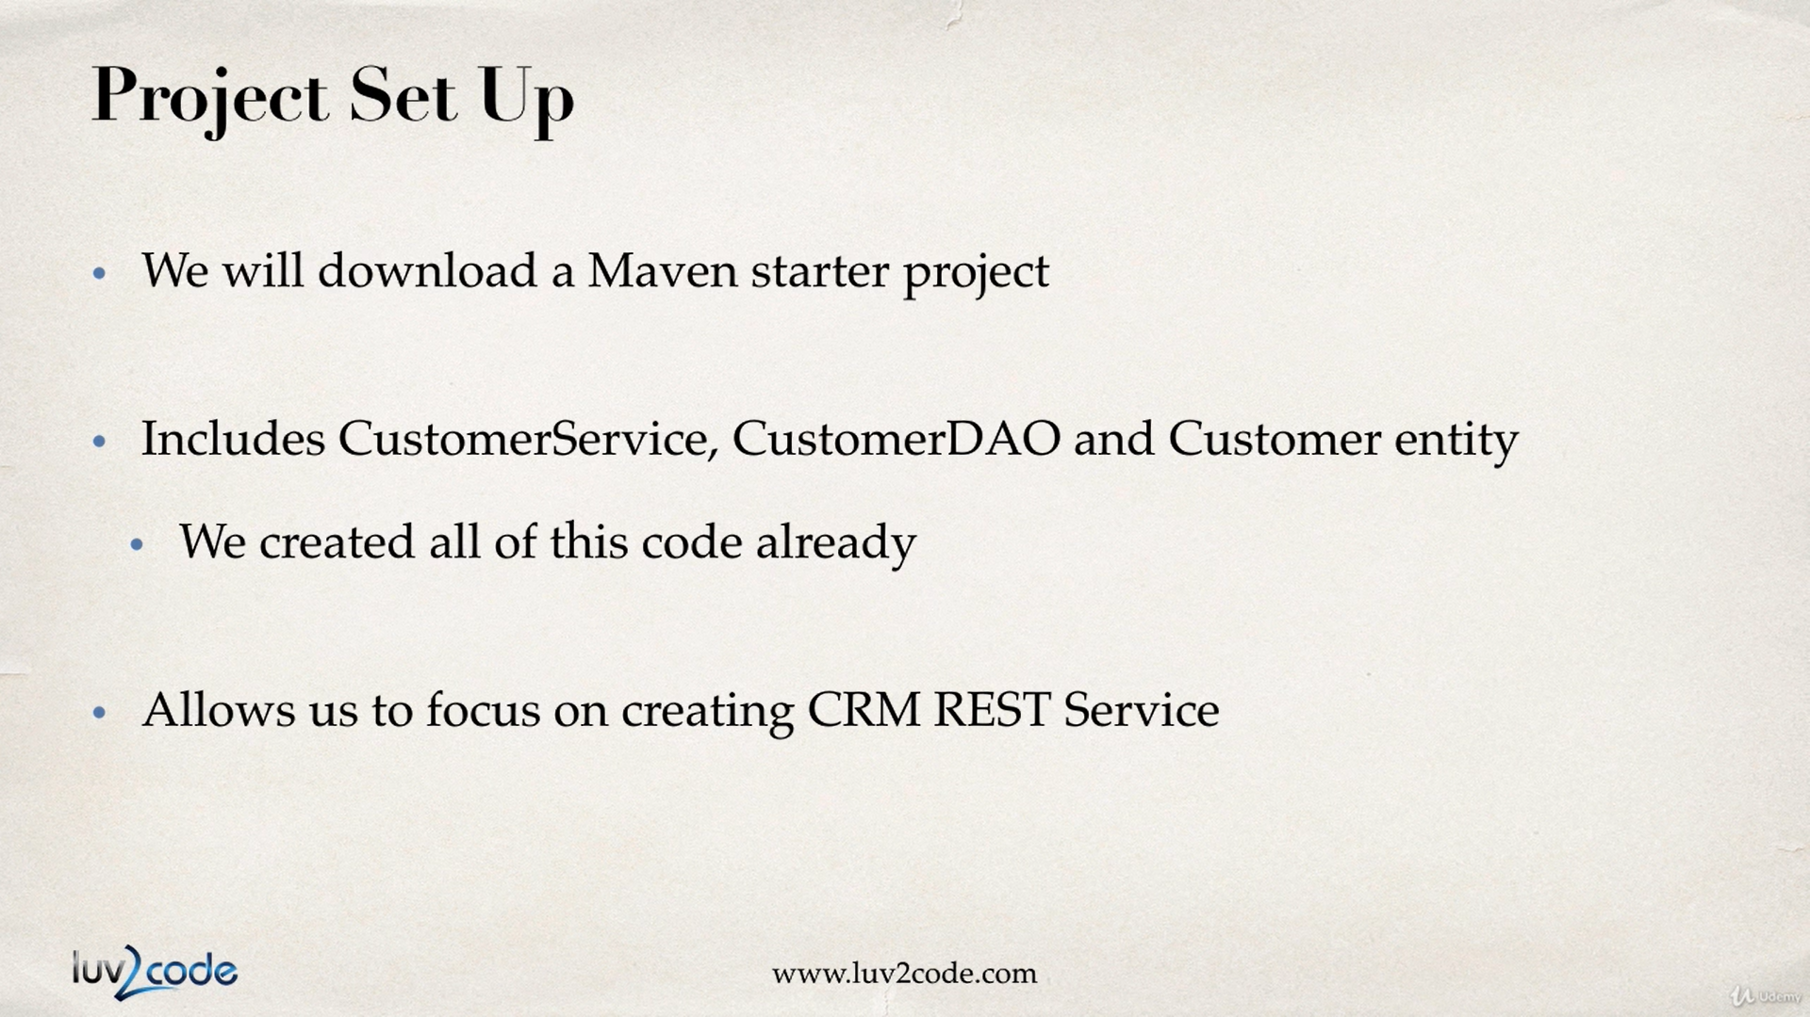

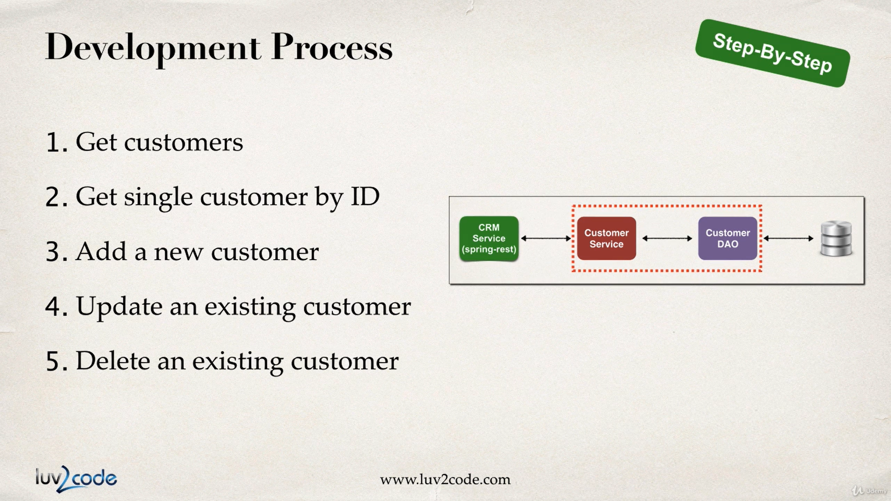

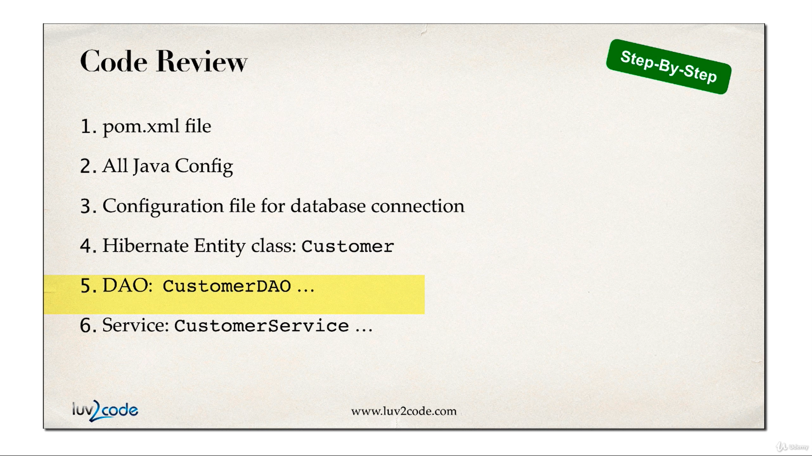

NOTE: we will copy our previous project where we set up our Entity class (**Customer**), introduce Service layer (**CustomerService**) and DAO layer (**CustomerDAO**)

So, **CustomerService** is the interface and **CustomerServiveImpl** is the implementation class of the **CustomerService** interface.

And **CustomerDAO** is the interface where we define the methods for GET, UPDATE, ADD and DELETE a customer and the DAO implementation class **CustomerDAOImpl** implements the **CustomerDAO** interface. The DAO layer will directly talk to the database using Hibernate framework

We will quickly go through what we have done in our previous project

1. Look at the Folder Structure

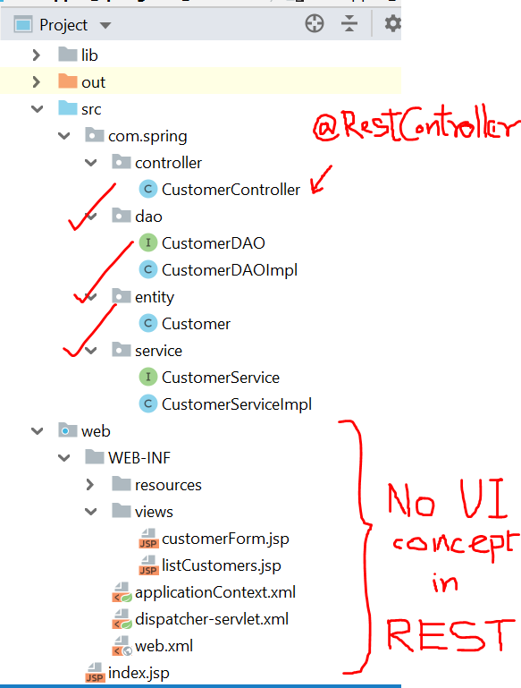

From our previous project we will simply use the **Entity class, service and the DAO**. Since **REST** has no **UI concept**, **we will not create any JSP page to show the Customer data**. Only a Index.jsp page will be there as a landing page (when we run the application in the browser). Where we just provide a direct link to GET all customers, otherwise you need to type the endpoint manually in the URL.

Let’s look at the folder structure of our current REST application project

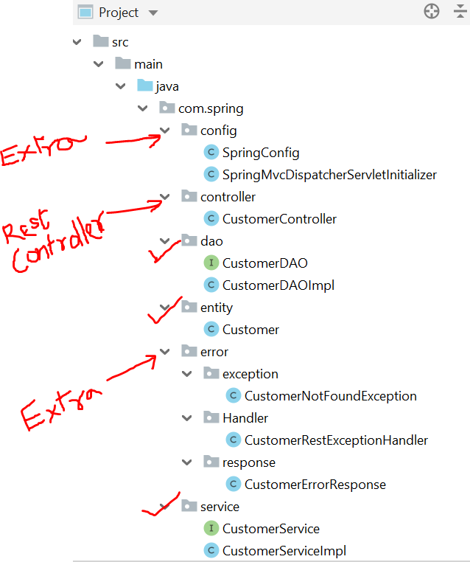

In this project we will additionally add a Configuration class for Spring (purely in JAVA, no XML config file) and introduce a custom Exception class to handle Spring REST Exceptions (Exception may occur when you run this REST application, we need to handle custom exceptions)

OKAY! Now let’s look at the Service Layer

* 1. **CustomerService.java**

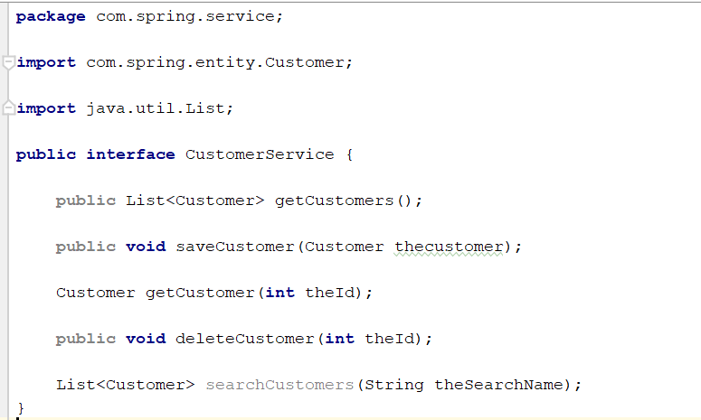

We have defined methods for

* Getting all customers (return a list of customers)
* Get a single customer ( method parameter integer) – provide the customer Id to get details
* Add or Save customer (parameter a Customer object) – this method will add a new customer or update an existing customer
* Delete a customer (method parameter integer) – provide the customer Id to delete a customer.
* Search a customer (method parameter String)
  1. **CustomerServiceImpl.java**

This class implements the Interface methods

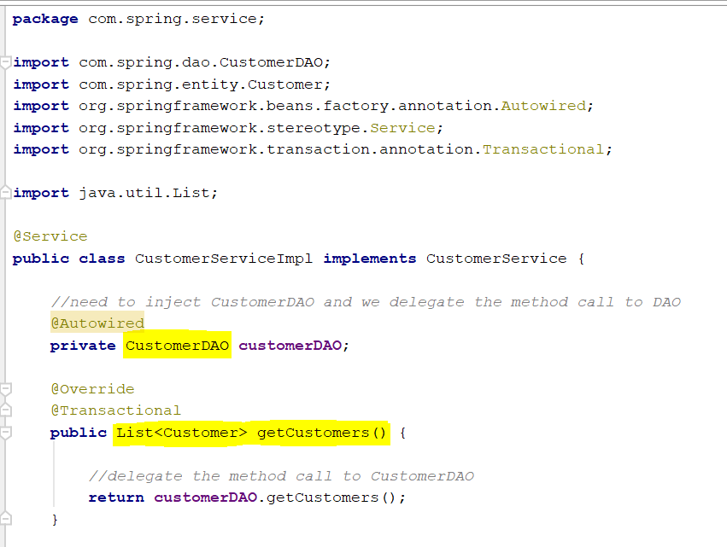

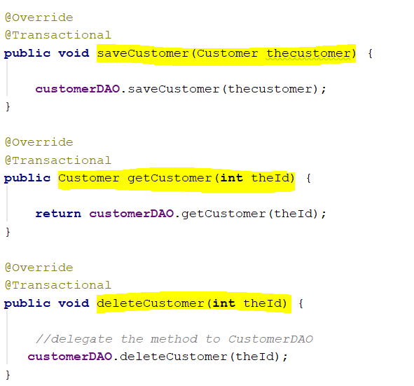

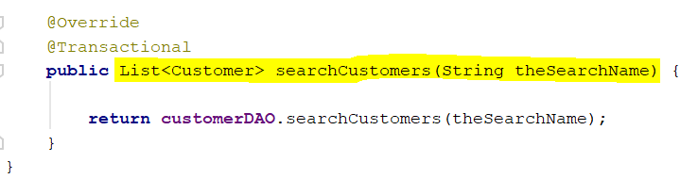

* 1. **CustomerDAO.java**

This is an interface that defines the methods to be implemented in the DAO layer

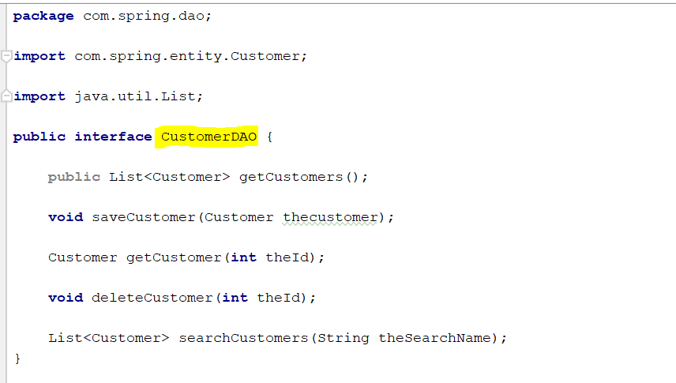

* 1. **CustomerDAOImpl.java**

Implements the methods of CustomerDAO interface. In our service implementation class, we just delegate the method call to the DAO. Now this CustomerDAOImpl is the actual implementation class where we actually write the code for add, get, delete and search for a customer

Since, DAO layer directly talk to the database using ORM tool (Hibernate) we will write Hibernate query to retrieve data, save data or search data.

Let’s look at the method body

* 1. **Customer.java**

STEPS

1. **Import Maven Dependencies**

To create the API, we need to define latest dependencies from central maven repository in our pom.xml file under <properties> element

1. **Spring framework (5.2.8.RELEASE)**

Which includes Spring MVC, Spring Transaction, Spring ORM support (in compatible version)

Spring MVC – Spring-webmvc includes REST support

Spring ORM – Spring supporting classes for using Hibernate

Spring tx – Spring transaction support for processing our data request

1. **Hibernate Support**

Add dependency for Hibernate-core (latest version)

1. **JDBC driver support- for POSTGRESQL**
2. **Maven compiler source and Maven compiler target**

Making the Project compatible to JDK 1.8

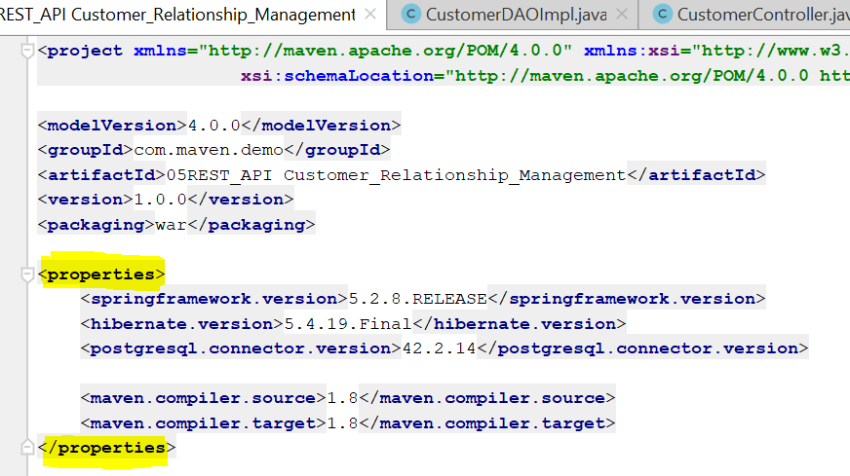

Next, we import dependencies inside <dependencies> tag

IMPORT

1. For SPRING support

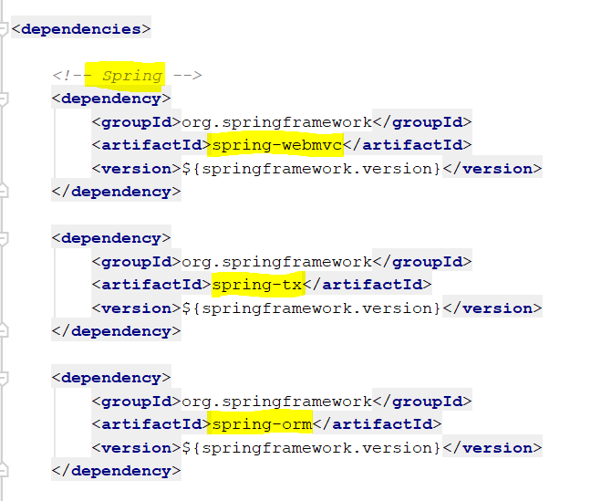

1. For Jackson support (Data Binding)

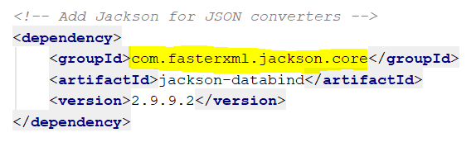

1. For Hibernate support

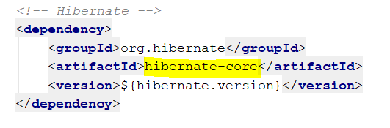

1. For PostgreSQL support

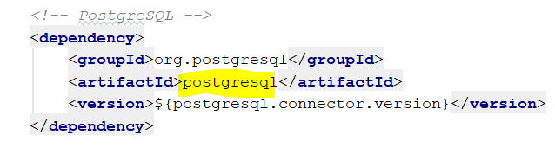

1. For Servlet JSP + JSTL support

Since we are not using xml file. We need to provide support for

‘**AbstractAnnotationConfigDispatcherServletInitializer**’ class to provide dispatcher servlet for the application

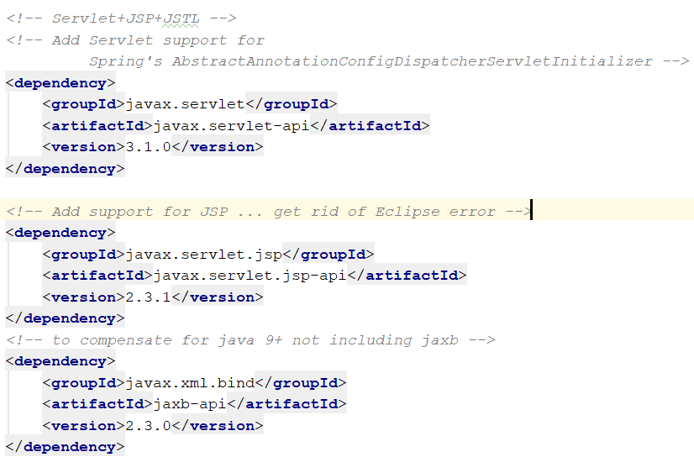

1. Add Build support for Maven war plugin

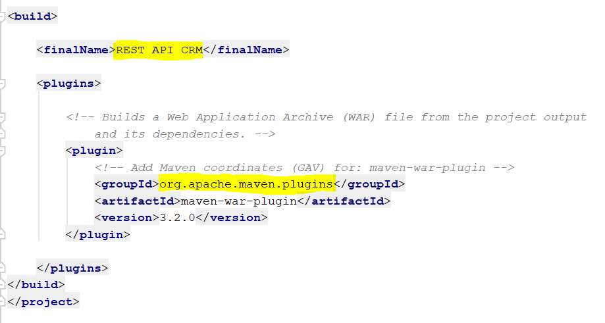

**NOTE:**

The WAR Plugin is responsible for collecting all artifact dependencies, classes and resources of the web application and packaging them into a web application archive

**OVERVIEW:**

1. [war: war](https://maven.apache.org/plugins/maven-war-plugin/war-mojo.html) is the default goal invoked during the package phase for projects with a packaging type of war. It builds a WAR file.
2. [war: exploded](https://maven.apache.org/plugins/maven-war-plugin/exploded-mojo.html) is generally used to speed up testing during the development phase by creating an exploded webapp in a specified directory.
3. [war:inplace](https://maven.apache.org/plugins/maven-war-plugin/inplace-mojo.html) another variation of war: explode where the webapp is instead generated in the web application source directory, which is src/main/webapp by default.
4. **Add Config.properties**

For set up JDBC connection properties and Hibernate properties

We will set up the values in a property file and in spring config file we will store these values in **Environment** type variable.

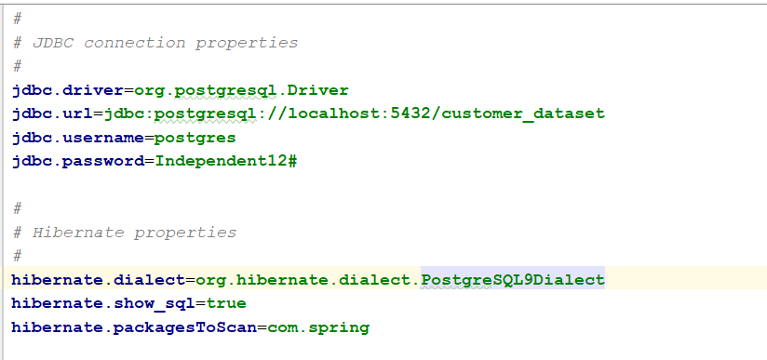

1. Configure Spring Configuration file

In the Spring configuration file, we need to configure a lot of things. Let’s look at one by one

* 1. To make Spring understand that it is a configuration file, we need to use **@Configuration** annotation to this class
  2. To provide Spring web MVC support (which further includes REST support) provide **@EnableWebMvc** annotation to this class
  3. Use **@EnableTransactionManagement** annotation for the Spring transaction support
  4. Use **@ComponentScan** annotation along with the base package name so that spring can automatically scan the component classes
  5. Use **@PropertySource** annotation to access the properties file where we configured the JDBC connection properties and Hibernate properties for Database implementation

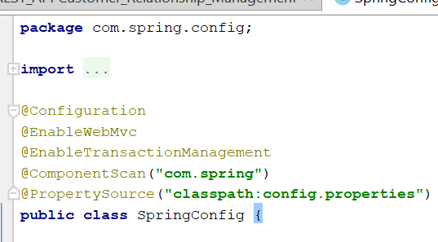

* 1. This class implements the **WebMvcConfigurer** interface
  2. Declare an **Environment** type variable to store the value from properties file
  3. Add the support for **logger**

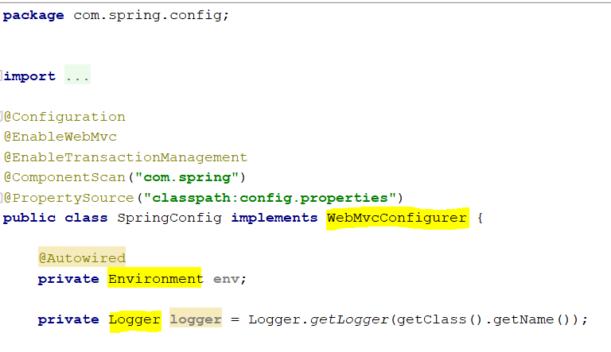

* 1. In our web.xml we define a session factory manager and a transaction manageras follows

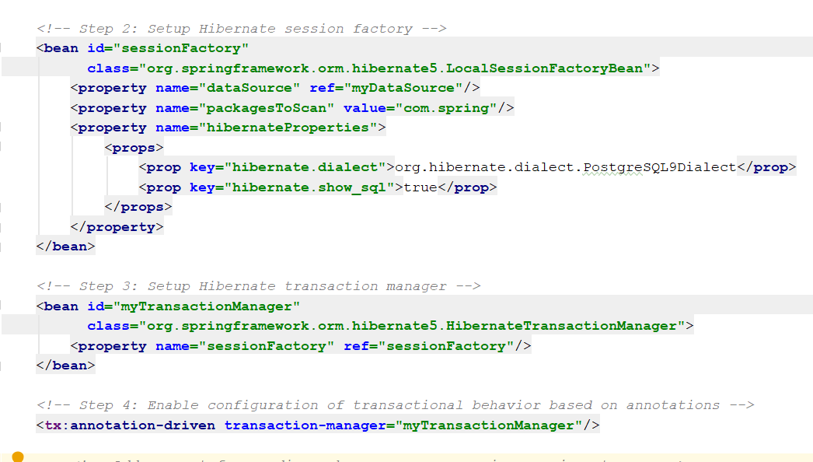

Similarly, we need to specify the bean for session factory and transaction manager using **@Bean** annotation

**First**, set data source connectivity and the values we get from properties file

**Environment.getProperty(“jdbc.driver”);** …like this

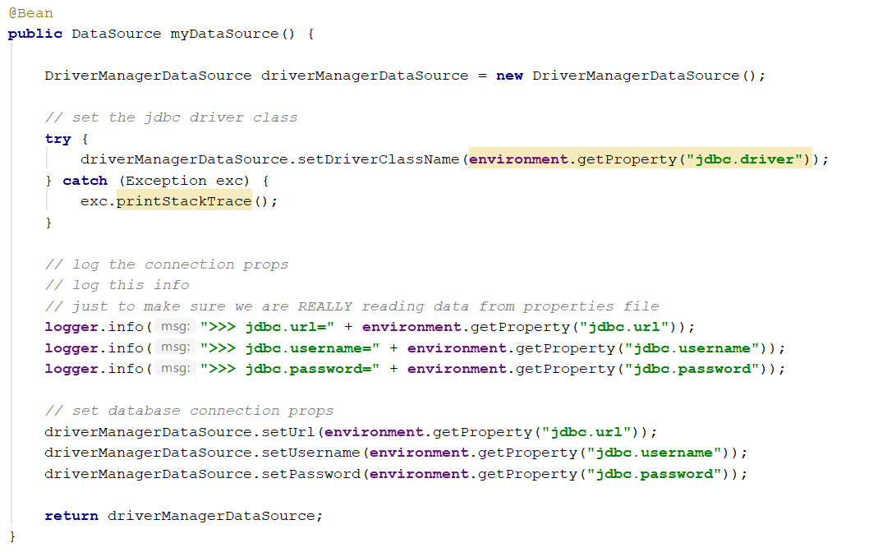

**Second**, set the Hibernate properties in a method

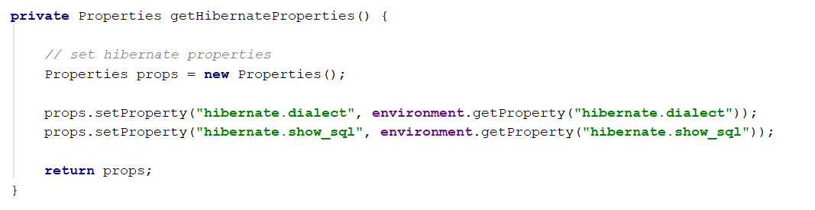

**Third**, create a method to configure Hibernate session factory

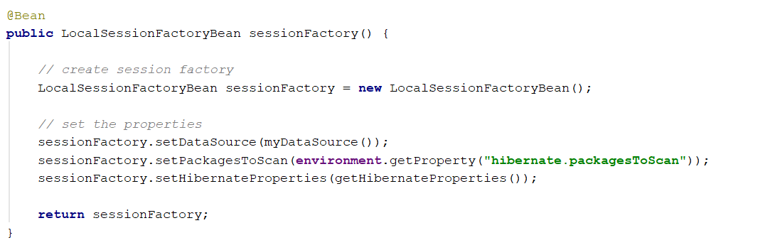

**Fourth**, create a method to configure Hibernate transaction manager

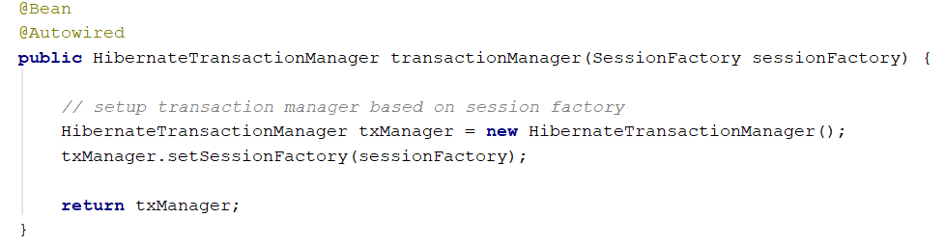

NOTE: since this is a REST application, we do not need a view resolver in the configuration class

* 1. Again, remember that REST does not use JSP pages, but to test that our application is configured successfully or not we will add an **Index.jsp** page in webapp directory

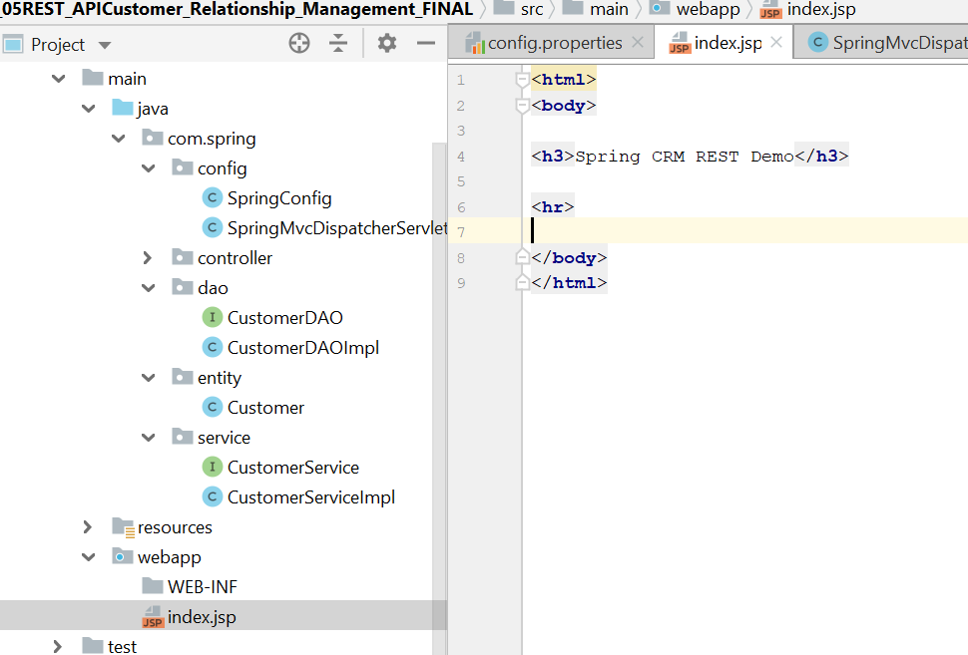

PART 02

NEW CODE HERE

Add a Customer Rest Controller

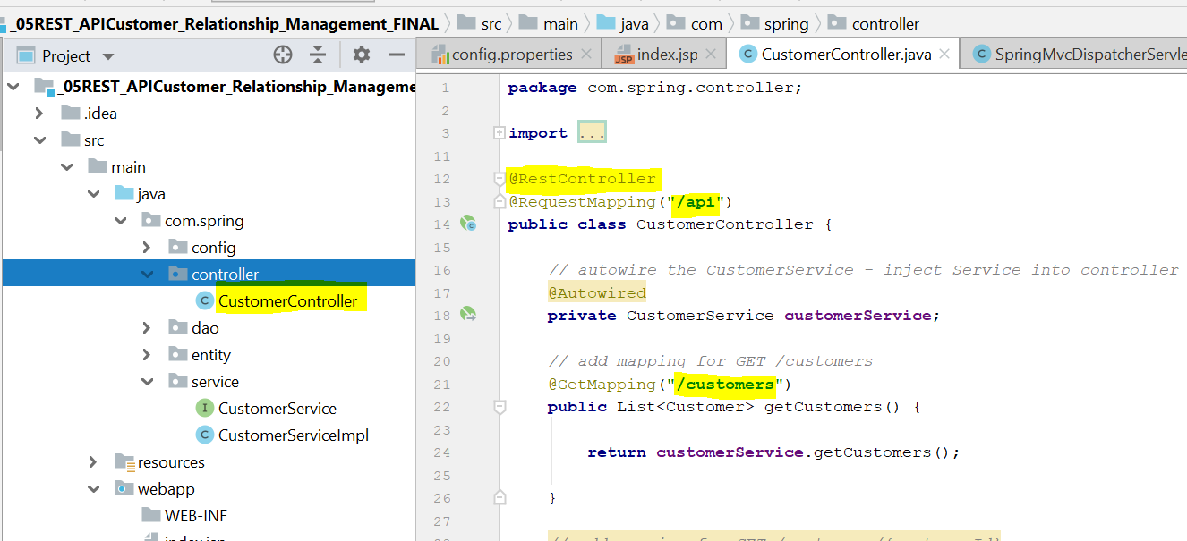

Add a link in index.jsp so that we do not need to manually type the endpoint

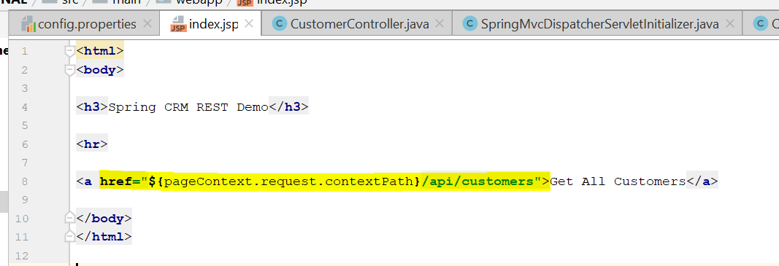

Run the application to test whether we can access the database using API and retrieve the data and display in JSON format

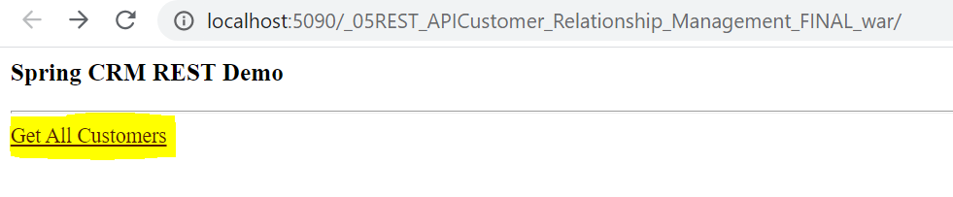

Click on **Get All Customers** link

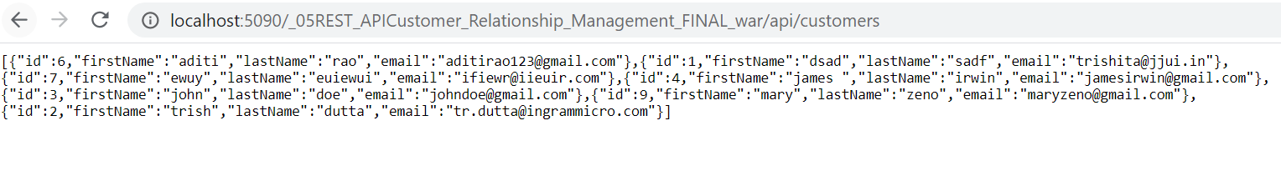

Copy the URL and in postman paste the URL

SUCCESS!

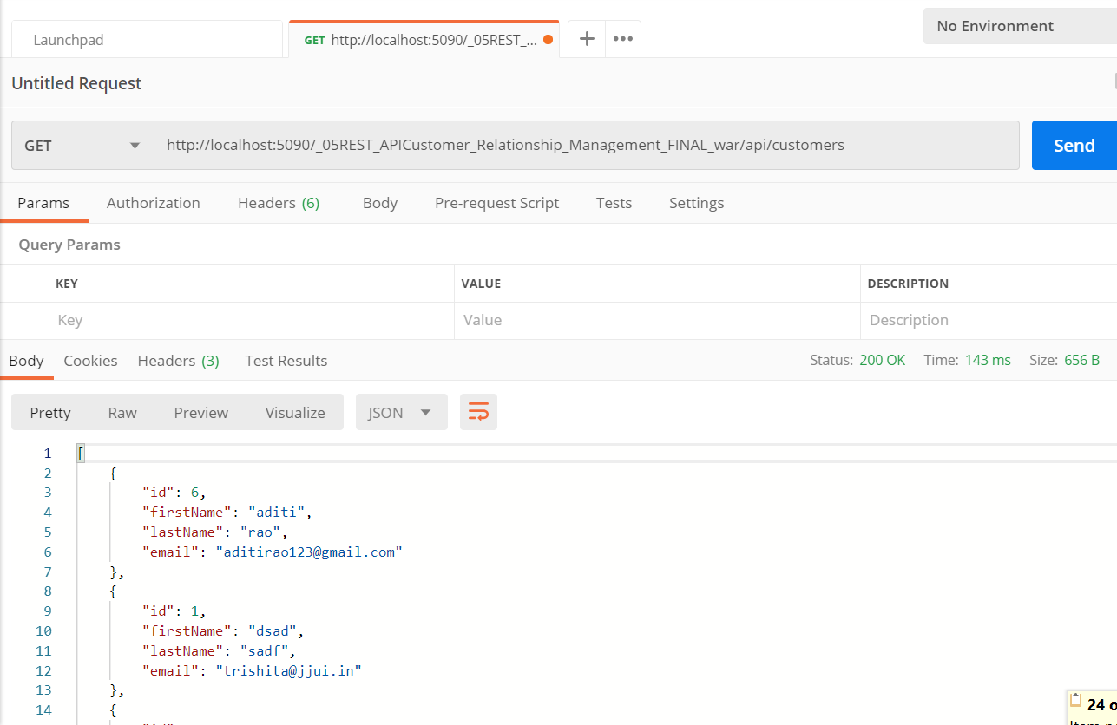

Get a single student data

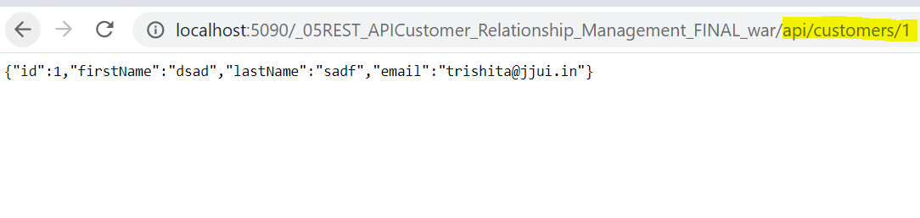

Okay ! so this is our first REST application talking to the database

Now we need to add a Global Exception handler so that we can send a custom error response in JSON format if anything wrong happens.

**Spring REST - EXCEPTION HANDLING**

STEPS

1. **Create a custom Error Response class**

Create an Error response class inside a new package ‘**error/response’**

This is simply a POJO class having the fields of the error message to be sent in JSON format and again JACKSON will do this conversion internally

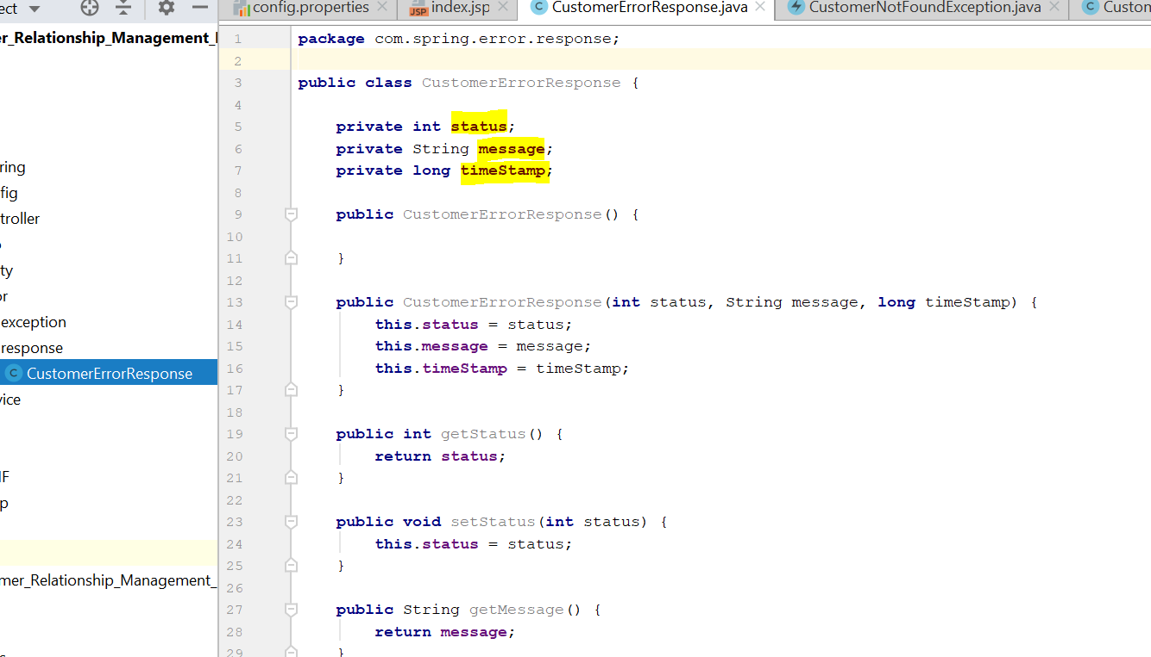

1. **Create Custom Exception class**

A custom Exception will be thrown if no matching customer is found in the database

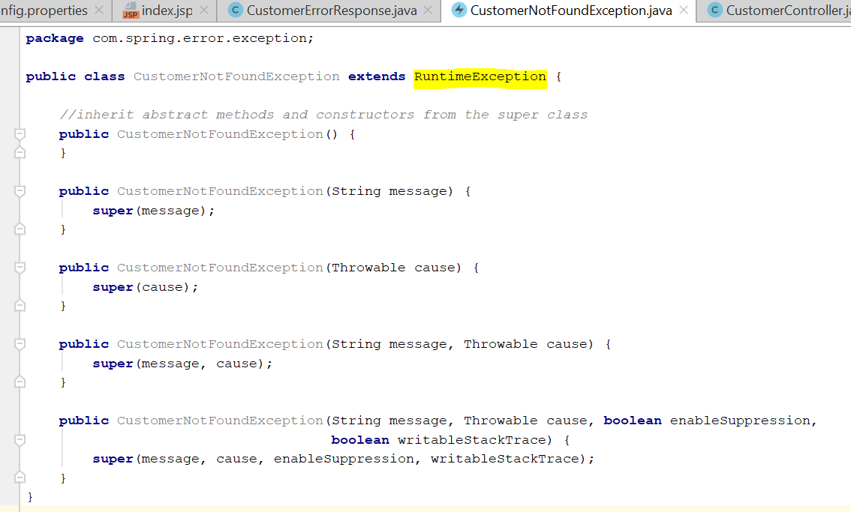

1. **Create an Exception handler class**

A class with **@ExceptionHandler** annotation will be created so that we can handle the exception and we will use query to check a customer is present in the database or not

**package** com.spring.error.Handler;  
  
**import** com.spring.error.exception.CustomerNotFoundException;  
**import** com.spring.error.response.CustomerErrorResponse;  
**import** org.springframework.http.HttpStatus;  
**import** org.springframework.http.ResponseEntity;  
**import** org.springframework.web.bind.annotation.ControllerAdvice;  
**import** org.springframework.web.bind.annotation.ExceptionHandler;  
  
@ControllerAdvice  
**public class** CustomerRestExceptionHandler {  
  
 *// Add an exception handler for CustomerNotFoundException* @ExceptionHandler  
 **public** ResponseEntity<CustomerErrorResponse> handleException(CustomerNotFoundException exc) {  
  
 *// create CustomerErrorResponse* CustomerErrorResponse error = **new** CustomerErrorResponse(  
 HttpStatus.***NOT_FOUND***.value(),  
 exc.getMessage(),  
 System.*currentTimeMillis*());  
  
 *// return ResponseEntity* **return new** ResponseEntity<>(error, HttpStatus.***NOT_FOUND***);  
 }  
  
 *// Add another exception handler ... to catch any exception (catch all)* @ExceptionHandler  
 **public** ResponseEntity<CustomerErrorResponse> handleException(Exception exc) {  
  
 *// create CustomerErrorResponse* CustomerErrorResponse error = **new** CustomerErrorResponse(  
 HttpStatus.***BAD_REQUEST***.value(),  
 exc.getMessage(),  
 System.*currentTimeMillis*());  
  
 *// return ResponseEntity* **return new** ResponseEntity<>(error, HttpStatus.***BAD_REQUEST***);  
 }  
}

1. **Check Exception inside try block inside Rest Controller**

(inside Get method for a single customer)

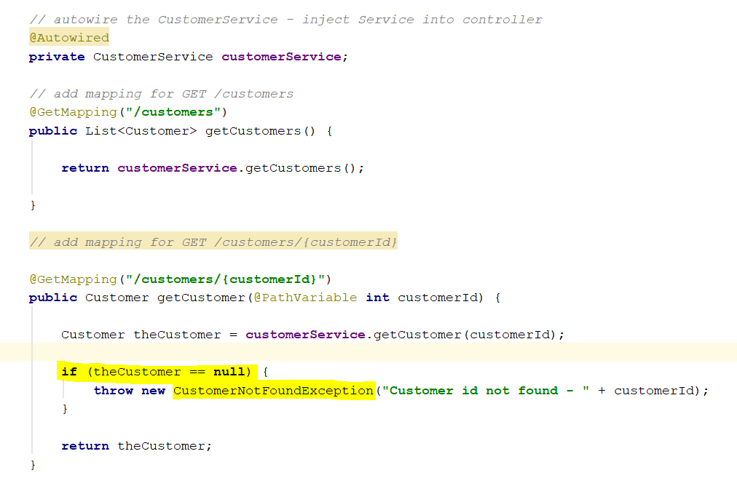  
POST request to create a new customer

